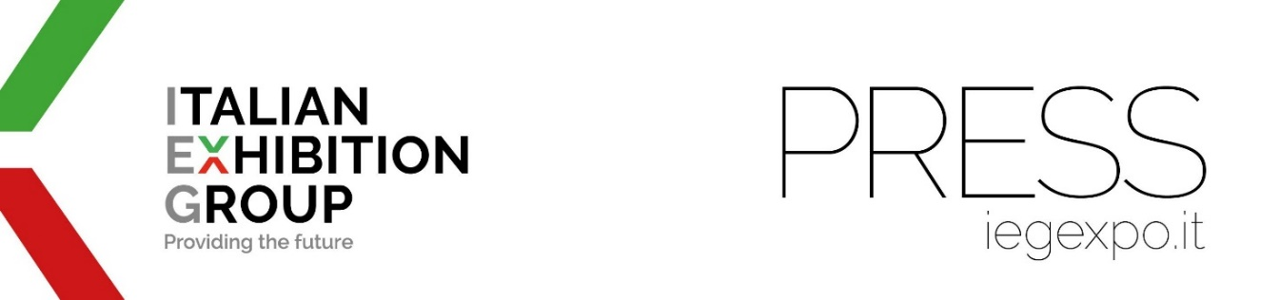

press release
(English translation)

193 FLAGS “FLY” OVER IEG

- In just 6 months and analysing only 8 trade shows on the calendar, Italian Exhibition Group has attracted 82,905 foreign visitors to Rimini and Vicenza
- While all the structured economies are represented, there is no lack of "surprises"
- Among the most “unusual” origins: Christmas Island, American Samoa, the Republic of Nauru

Rimini 2 April 2024 - Around the world in 51 trade shows. The “flags” of operators who have attended Italian Exhibition Group (IEG) trade shows in Rimini and Vicenza are flying for 193 out of the approximately 200 recognised countries around the globe. This is the result of the exhibition-congress group’s recent international strategy structured between global expansion and incoming buyers that has generated a virtuous circular network of attendance and business.

The origins of IEG's international visitors (82,905 foreign presences recorded in just six months and with only eight trade fairs surveyed - TTG TRAVEL EXPERIENCE, ECOMONDO, SIGEP, VICENZAORO in its two editions, BEER&FOOD ATTRACTION, KEY, ENADA) are the most diverse.

In terms of absolute numbers and by cross-referencing the data of the 8 shows, Spain, Germany and France stand on the podium followed by, among others, the United States, Turkey, Great Britain, Switzerland and Belgium. In 15th place is Portugal with India fast at heel. China is twentieth while the Arab Emirates and Brazil take the 23rd and 24th places respectively, Ukraine is 28th and Japan fills the 30th spot.
All countries with structured economies are obviously represented (Sweden, Morocco, Singapore, Australia, South Africa, Saudi Arabia, to name but a few) but there is no shortage of “surprises”.

Ecomondo, the number one trade show for the green economy, hosted buyers in Rimini from the Republic of Nauru, an island state in Oceania, known for being the smallest republic in the world with its 10,000 inhabitants.
Other operators attended Rimini Expo Centre from the Caribbean state of Saint Vincent and the Grenadines - famous for its luxurious private islands - to see the wonders of the dolce food service at Sigep.
Attracted by high jewellery, several operators from the Turks and Caicos Islands, an archipelago of 40 coral islands lying in the Atlantic Ocean south-east of the Bahamas, attended Vicenzaoro.
Some of TTG's buyers came to Rimini from afar to find out all about the world of tourism, even from the Cocos Islands, in the Indian Ocean south-east of Jakarta.
Reviewing the latest developments in the world of renewable energy at KEY, again in Rimini, were operators from Christmas Island located in the middle of the Pacific Ocean on the same longitude as New Guinea and Ecuador, more or less equidistant from the two faraway countries: it is the planet's first merged territory.

Also represented was the place that celebrates New Year's Eve last: American Samoa (together with the Caroline Islands), with buyers in attendance at Rimini Expo Centre at both TTG and Beer&Food Attraction.
The gaming world with ENADA also saw trade operators in Rimini from Togo, the state overlooking the Gulf of Guinea.
A special mention for Reunion in the Indian Ocean, an island known for its volcanic rainforest-covered hinterland, beaches and coral reefs. Its many buyers divided their time between Vicenza and Rimini to visit Beer&Food Attraction, Vicenzaoro and Sigep.

PRESS CONTACT IEG: media@iegexpo.it;

PRESS CONTACT ITALIAN EXHIBITION GROUP | media@iegexpo.it
head of corporate communication & media relations: Elisabetta Vitali|
press office manager: Marco Forcellini | international press office coordinator: Silvia Giorgi

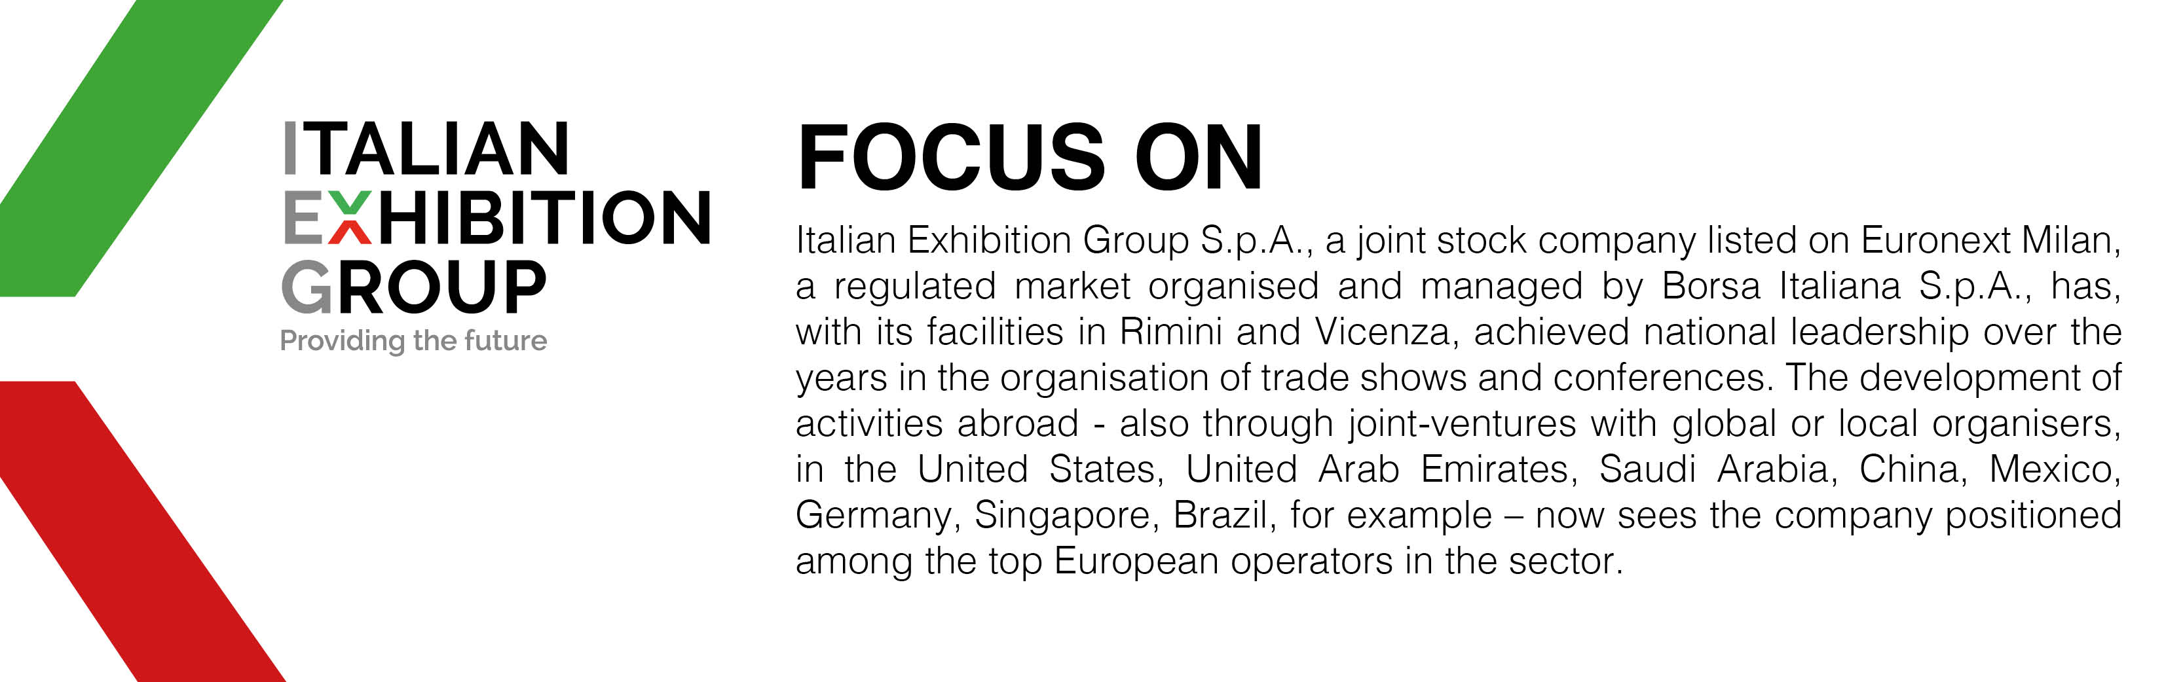

This press release contains forecast elements and estimates that reflect the management’s current opinions (“forward-looking statements”), particularly regarding future management performance, realization of investments, cash flow trends and the evolution of the financial structure. For their very nature, forward-looking statements have a component of risk and uncertainty, as they depend on the occurrence of future events. The effective results may differ (even significantly) from those announced, due to numerous factors, including, only by way of example: food service market and tourist flow trends in Italy, gold and jewellery market trends, green economy market trends; the evolution of raw material prices; general macroeconomic conditions; geopolitical factors and evolutions in the legislative framework. Moreover, the information contained in this release does not claim to be complete, and has not been verified by independent third parties. Forecasts, estimates and objectives contained herein are based on the information available to the Company as at the date of this release.

